ISD TERM PROJECT
<Software Requirements Specification>

MediAlert — Medicine Reminder & Health Tracker



Project Advisor

Ayesha Zaheer

Presented by:
Group ID: SE_IISS

Sr. No. | Student Name | Registration No.
1 | Muhammad Irtaza | L1F24BSCS0593
2 | Muhammad Imran Butt | L1F24BSCS0546
3 | Muhammad Salman Amjad | L1F24BSCS0553
4 | Sarmad Amin | L1F24BSCS0716

Faculty of Information Technology

University of Central Punjab

Software Requirements Specification

Version <Version # 1.0.0>

<MediAlert>

Advisor: Ayesha Zaheer

Group <Group ID>

Member Name | Primary Responsibility | % Contribution | Roll No | Serial # | Sign

Table of Contents
Table of Contents iii
List of Figures v
List of Tables vi
Revision History vii
1. Introduction and Background 1
1.1 Product (Problem Statement) 1
1.2 Background 1
1.3 Scope 1
1.4 Objective(s)/Aim(s)/Target(s) 1
1.5 Challenges 1
1.6 Learning Outcomes 1
1.7 Nature of End Product 1
1.8 Completeness Criteria 1
1.9 Business Goals 1
1.10 Related Work/ Literature Survey/ Literature Review 1
1.11 Document Conventions 1
2. Overall Description 2
2.1 Product Features 2
2.2 User Classes and Characteristics 2
2.3 Operating Environment 2
2.4 Design and Implementation Constraints 2
2.5 Assumptions and Dependencies 2
3. Project Management. 3
3.1 Work Breakdown Structure (WBS). 3
3.2 Create Milestone table 3
3.3 Develop an Activity Graph. 3
3.4 Find the Critical Path. 3
3.5 Create a Gantt chart. 3
~~~~~~~~~~ Phase II ~~~~~~~~~~ 4
4. Functional Requirements 4
4.1 Name of Use-Case 1 4
4.2 Name of Use-Case 2 (and so on) 4
Requirements Analysis and Modeling 5
5. Nonfunctional Requirements* 6
5.1 Performance Requirements 6
5.2 Safety Requirements 6
5.3 Security Requirements 6
5.4 Additional Software Quality Attributes 6
6. Other Requirements 7
7. Designing 8
7.1 Complete class diagram 8
7.2 Complete Data Flow Diagram (DFD) 8
7.3 Complete ER Diagram 8
7.4 Physical design of your database 8
7.5 Information on use of design patterns while designing the modules 8
7.6 Make a Sequence and a Collaboration diagram of following. 8
7.6.1 Scenario 1 8
7.6.2 Scenario 2 8
8. Estimation 9
8.1 Cost Benefit Estimation 9
8.1.1 Return of Investment (ROI) {1st year} 9
8.1.2 %gain on ROI {1st year} 9
8.1.3 Payback Period in years 9
8.2 FP based Estimation 9
8.3 COCOMO Estimation 9
9. References 10
Appendix A: Glossary 11

List of Figures

List of Tables

Revision History
Name | Date | Reason For Changes | Version

Introduction and Background
MediAlert is an Android mobile application developed to address a critical healthcare challenge: medication non-adherence. The application targets patients, elderly individuals, and caregivers who struggle to manage complex medication schedules. Medication non-adherence is a globally recognized public health issue that leads to worsening chronic conditions, preventable hospitalizations, and increased healthcare costs. MediAlert aims to provide a simple, free, and offline-first solution to help users track their medicines, log vitals, and respond to medical emergencies — all from a single Android application.

Product (Problem Statement)
MediAlert is an Android mobile application designed to help patients, elderly individuals, and caregivers manage medication schedules effectively. The application provides medicine reminders with alarm notifications, a health vitals tracker, a medicine history log, and an emergency contact feature. It is built using MIT App Inventor and stores all data locally on the device using TinyDB, making it completely free to build and use with no internet connection required. The core problem it solves is medication non-adherence, millions of patients worldwide, particularly the elderly, forget to take their medicines on time, leading to worsening chronic illnesses, increased hospital visits, and in some cases, life-threatening consequences.

Background (Problem Statement)
The domain of this project is mobile health (mHealth), specifically medication management and patient self-care applications. Chronic diseases such as diabetes, hypertension, and heart disease require patients to follow strict, often complex medication regimens on a daily basis. Studies in healthcare informatics show that approximately 50% of patients with chronic conditions do not take their medications as prescribed . This leads to disease progression, emergency hospital admissions, and a significant burden on healthcare systems. In Pakistan, where access to regular medical supervision is limited for many patients, the need for a simple, low-cost self-management tool is particularly acute. Existing solutions in the market are either too expensive, require constant internet access, or are too complex for elderly users. MediAlert addresses this gap by providing a free, offline, and easy-to-use Android application tailored to local user needs.

Scope
This SRS covers the full software requirements for the MediAlert Android application. The scope of the system includes:
(1) user account management (sign up, login, profile management); (2) medicine management (add, edit, delete, and list medicines with dosage and frequency); (3) reminder and notification functionality (daily alarms with mark as Taken or Skipped); (4) medicine history log (daily records, date filtering, consistency streaks); (5) vitals tracker (blood pressure, blood sugar, and weight logging with history); (6) weekly health reports (summary of adherence and vitals trends); and (7) emergency contact feature (one-tap emergency call). The system operates entirely on a single Android device with no server-side components, cloud storage, or internet dependency. Multi-device synchronization, telemedicine integration, and prescription management are explicitly out of scope for this version.

Objective(s)/Aim(s)/Target(s)
The following objectives are to be achieved upon completion of the MediAlert project:

- To develop a fully functional Android application that sends medicine reminders at user-defined times.

(2) To enable users to log and track their health vitals (blood pressure, blood sugar, weight) over time.

(3) To provide a medicine history log that records taken and missed doses with date filtering.

- To generate a weekly health report summarizing medication adherence and vitals trends.

- To implement an emergency contact feature that enables a one-tap call to a saved contact.

- To build the entire application using MIT App Inventor at zero cost.

(7) To deliver a user interface that is simple enough for elderly users with minimal technical expertise.

Challenges
The following challenges were anticipated during the development of MediAlert:

- Implementing reliable timed notifications using the MIT App Inventor Clock component, which requires careful handling of background processes on Android.

- Designing a user interface that is accessible to elderly users with large text, simple navigation, and minimal steps to complete tasks.

- Managing all application data locally using TinyDB without a relational database, requiring careful key-value data structuring to simulate records and relationships.

- Ensuring the medicine reminder system continues to function even if the app is closed or the phone is restarted.

- Building a consistent streak and history log system without server-side support.

(6) Coordinating team responsibilities across four members while working with a visual development tool that does not support version control natively.

Learning Outcomes
Through the development of MediAlert, the team will achieve the following learning outcomes:

- Gain hands-on experience in applying the Software Development Life Cycle (SDLC) to a real-world project from requirements gathering through to prototyping.

- Develop proficiency in writing a complete Software Requirements Specification (SRS) document including functional requirements, non-functional requirements, and UML diagrams.

- Practice visual application development using MIT App Inventor and understand event-driven programming paradigms.

- Learn to model software systems using use-case diagrams, activity diagrams, class diagrams, sequence diagrams, ERDs, and DFDs.

(5) Collaborate as a team, divide responsibilities, and integrate contributions into a single deliverable.

Nature of End Product
The end product of this project is a working Android mobile application prototype. The application is a standalone, offline, single-user system built entirely on the MIT App Inventor platform. It consists of approximately 8-10 screens covering user authentication, medicine management, reminder notifications, history logging, vitals tracking, weekly reporting, and emergency contact functionality. The deliverable includes the complete source project file (.aia) exportable from MIT App Inventor and an installable Android package (.apk) file that can be side-loaded onto any Android device running Android 5.0 (Lollipop) or higher. The application stores all data locally using the TinyDB component, requires no internet connection during use, and is available at zero cost to build, test, and deploy.

Completeness Criteria
The MediAlert project will be considered complete when all of the following criteria are met:

- A user can successfully sign up, log in, and manage their profile.

- At least one medicine can be added with a name, dosage, frequency, and reminder time, and a notification fires at the scheduled time.

- The user can mark a dose as Taken or Skipped, and the history log correctly reflects this entry.

- At least one vitals entry (blood pressure, blood sugar, or weight) can be logged and viewed in history.

- A weekly report screen displays a summary of medicines taken vs. skipped for the past 7 days.

- An emergency contact can be saved and dialed with a single tap from the home screen.

- All desired application screens are functional and navigable without crashes.

(8) The APK file can be installed and run on a physical Android device or emulator.

Business Goals
MediAlert addresses the following business and social goals:

- Improve Medication Adherence, Reduce the rate of missed doses among patients managing chronic conditions such as diabetes, hypertension, and heart disease.

- Reduce Preventable Hospitalizations, By reminding patients to take their medicines on time, the app aims to reduce emergency visits caused by medication non-compliance.

- Empower Caregivers, Provide family members and caregivers a simple tool to help manage medication schedules for elderly or dependent patients.

- Zero-Cost Healthcare Tool, Deliver a fully functional health management application at no cost to the end user, increasing accessibility for low-income users in Pakistan and similar markets.

(5) Demonstrate Academic Competency, Showcase the team’s ability to design, document, and prototype a real-world software solution as part of the SE203 course deliverables.

Related Work/ Literature Survey/ Literature Review

Several existing applications address medication management. Medisafe (Medisafe Inc., 2012) is a widely used medicine reminder app available on Android and iOS; it supports multiple users and cloud sync but requires an internet connection and account registration, making it inaccessible in offline environments. MyTherapy ( 2015) offers reminders, a health journal, and vitals tracking but is feature-heavy and complex for elderly users. Research by Vervloet et al. (2012) in the British Journal of Clinical Pharmacology demonstrated that SMS and app-based reminders significantly improve medication adherence in chronic disease patients. A systematic review by Dayer et al. (2013) published in the journal of American Phrarmacists Association confirmed that mobile apps are effective tools for improving adherence when designed with simplicity and offline capability in mind. MediAlert differentiates itself by being completely free, offline-first, built on MIT App Inventor (requiring no coding), and specifically designed for the Pakistani user context with a simple interface suitable for elderly individuals.

Document Conventions
This SRS follows standard IEEE 830 conventions for software requirements documentation. The following typographical conventions apply throughout this document:

- Section headings are formatted in bold using Heading 1 and Heading 2 styles.

- Placeholder text from the template is replaced with MediAlert-specific content in normal body text.

- The term “User” refers to any of the three user classes: Patient, Elderly Person, or Caregiver, unless a specific class is named.

- The term “System” refers to the MediAlert Android application.

- Use-case identifiers follow the format UC-N where N is a sequential integer.

(6) Requirements are stated in active voice using the word “shall” to indicate mandatory behaviour and “should” for desirable behaviour.

Overall Description

Product Features
MediAlert provides the following major features:

- User Account Management: Users can sign up with their name, age, and phone number, log in and out securely, and view or edit their profile at any time.

- Medicine Management: Users can add medicines with name, dosage, and frequency; set reminder times (once, daily, or multiple times per day); and edit or delete any medicine from their list.

- Reminders and Notifications: The system fires a daily alarm notification at the set reminder time displaying the medicine name and dosage. Users can mark each dose as Taken or Skipped, and missed doses are automatically logged.

- Medicine History Log: Users can view a daily record of medicines taken and skipped, filter by date, and track their consistency streak.

- Vitals Tracker: Users can log blood pressure (systolic and diastolic), blood sugar level, and weight, and view historical entries for each vital.

- Weekly Health Report: A summary screen shows medicines taken vs. skipped for the week along with a 7-day vitals trend.

- Emergency Feature: A one-tap emergency call button on the home screen dials a saved emergency contact.

(8) Settings: Users can edit their profile, toggle reminder sound, update their emergency contact, and clear all app data.

User Classes and Characteristics
MediAlert serves three user classes based on the system's class hierarchy. The base class is User, which represents any registered account in the system. User has two specialized subclasses: Patient and Caregiver.
(1) User: The base class for all system accounts. Any person who uses MediAlert must first register and log in. The User class provides common functionality including signup, login, logout, and profile editing. All users are expected to own an Android smartphone and have basic literacy.
(2) Patient: The primary and most important user class. A Patient is an individual who takes regular medicines for chronic or acute conditions such as diabetes, hypertension, or heart disease. Patients use the full range of application features: viewing their medicine list, marking doses as taken or skipped, logging vitals (blood pressure, blood sugar, weight), viewing medicine history, generating weekly reports, and making emergency calls. This user class drives the core requirements of the system.
(3) Caregiver: A secondary user class representing a family member, nurse, or attendant who manages medication on behalf of a patient. A Caregiver can add and manage patient profiles, configure medicines and reminders for patients, and view patient history and weekly reports. Caregivers may not use the app on a daily basis but require full access to medicine management and reporting features.

Operating Environment
MediAlert operates in the following environment:

Hardware Platform: Any Android smartphone or tablet with a minimum of 1 GB RAM, 50 MB of free internal storage, and a working speaker for alarm notifications. A camera or fingerprint sensor is not required.

Operating System: Android 5.0 (Lollipop) or higher. The application is built using MIT App Inventor which compiles to a standard Android APK compatible with all modern Android versions.

Development Environment: MIT App Inventor (browser-based IDE at appinventor.mit.edu) running on any modern web browser (Google Chrome recommended).

Testing Environment: Android Emulator provided within MIT App Inventor for development testing, and a physical Android device for final acceptance testing.

Dependencies: The application uses only built-in MIT App Inventor components (TinyDB, Clock, Notifier, PhoneCall, TextBox, Spinner) and has no dependency on external libraries, APIs, or internet connectivity during runtime.

Design and Implementation Constraints
The following constraints apply to the design and implementation of MediAlert:
- Platform Constraint: The application must be built exclusively using MIT App Inventor. This restricts the use of custom native Android code, third-party UI libraries, and advanced database engines.

- Storage Constraint: All data must be stored locally using TinyDB, a key-value store built into MIT App Inventor. This means no relational database, no complex queries, and no multi-device data synchronization is possible.

- Single-User Constraint: The application supports only one user profile per device. Multiple user accounts on the same device are out of scope.

- Offline-Only Constraint: No internet connectivity is assumed or required. Features such as cloud backup, remote monitoring, or doctor-patient communication are excluded.

- Android-Only Constraint: The application targets Android only. iOS support is not in scope given the MIT App Inventor platform limitation.

Assumptions and Dependencies
The following assumptions and dependencies apply to the MediAlert project:

Assumptions:

- It is assumed that the target user owns an Android smartphone running Android 5.0 or above.

- It is assumed that the user has basic literacy and can read medicine names and dosage instructions.

- It is assumed that the device has a functioning alarm or notification system that is not silenced or blocked by battery optimization settings.

- It is assumed that users will configure their medicine reminders correctly at the time of adding a medicine.

- It is assumed that the phone’s date and time settings are correctly configured, as reminder accuracy depends on the system clock.

Dependencies:

- The application depends on the MIT App Inventor platform for development and APK compilation; any downtime or policy changes on the platform could affect the build process.

- The Clock component in MIT App Inventor is relied upon for all reminder functionality; its behaviour may vary across Android manufacturers due to battery optimization policies.

(3) The PhoneCall component depends on the device having an active SIM card and network coverage for the emergency call feature to function.

Project Management.

Work Breakdown Structure (WBS).
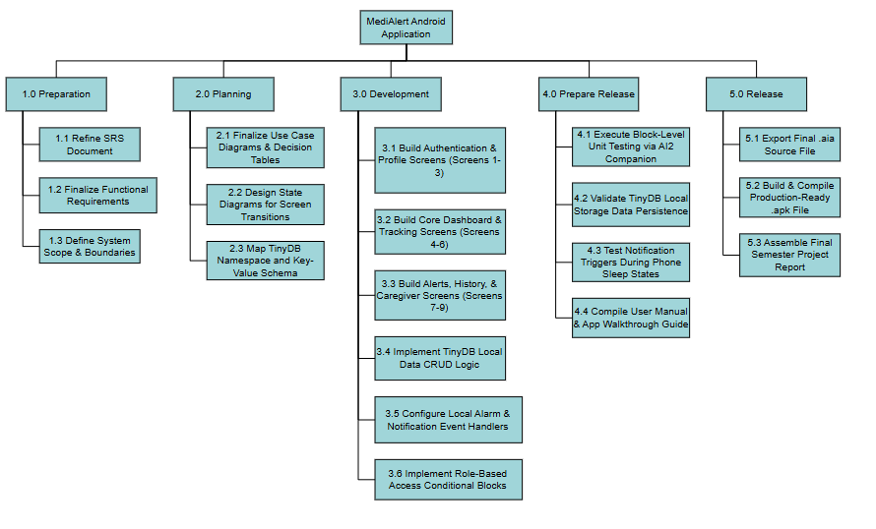

Create Milestone table

Milestone | Activity | Duration (Days)
M1 | Requirement Gathering & SRS Finalization | 5
M2 | System Design (Use Cases & State Diagrams) | 6
M3 | Database Design (TinyDB Key-Value Schema) | 3
M4 | Authentication & Profile Screens Setup (Screens 1-3) | 4
M5 | Core Tracking & Dashboard Screen Development (Screens 4-6) | 5
M6 | Alerts, History & Caregiver Screen Development (Screens 7-9) | 5
M7 | Logic Integration (TinyDB CRUD & Event Handlers) | 4
M8 | Integration Testing & Companion Debugging | 5
M9 | User Manual Writing & Presentation Preparation | 3

Develop an Activity Graph.
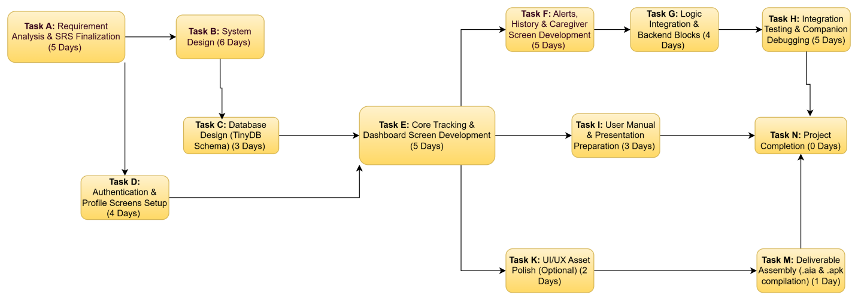

Find the Critical Path.

Path 1
A → B → C → E → F → G → H → N
Duration:
5 + 6 + 3 + 5 + 5 + 4 + 5 + 0 = 33 Days

Path 2
A → D → E → F → G → H → N
Duration:
5 + 4 + 5 + 5 + 4 + 5 + 0 = 28 Days

Path 3
A → B → C → E → I → N
Duration:
5 + 6 + 3 + 5 + 3 + 0 = 22 Days

Path 4
A → D → E → I → N
Duration:
5 + 4 + 5 + 3 + 0 = 17 Days

Path 5
A → B → C → E → K → M → N
Duration:
5 + 6 + 3 + 5 + 2 + 1 + 0 = 22 Days

Path 6
A → D → E → K → M → N
Duration:
5 + 4 + 5 + 2 + 1 + 0 = 17 Days

Critical Path
The longest path is:
A → B → C → E → F → G → H → N = 33 Days
So the Critical Path = Path 1 and the Project Duration = 33 Days.

Create a Gantt chart.

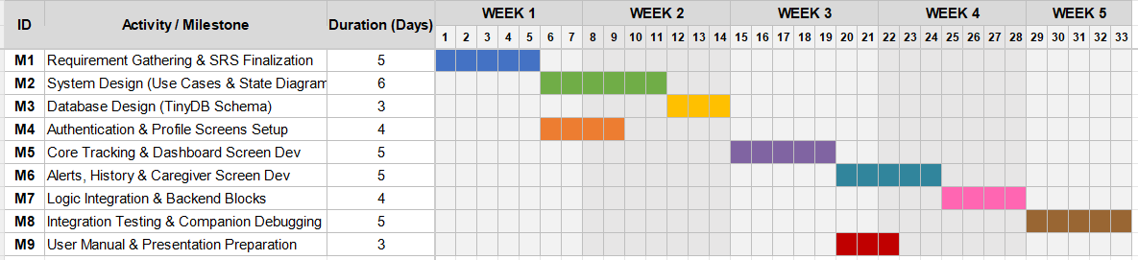

~~~~~~~~~~ Phase II ~~~~~~~~~~

Functional Requirements
<All functional requirements are expressed as use-cases. Fill out the following template for each use-case. Don’t really say “Use-Case 1.” State the use-case name in just a few words e.g. “Withdraw Cash from ATM”. A use-case may have multiple alternate courses of action.>

<Provide a Use Case Diagram before describing the use cases.>

Use Case Diagram:

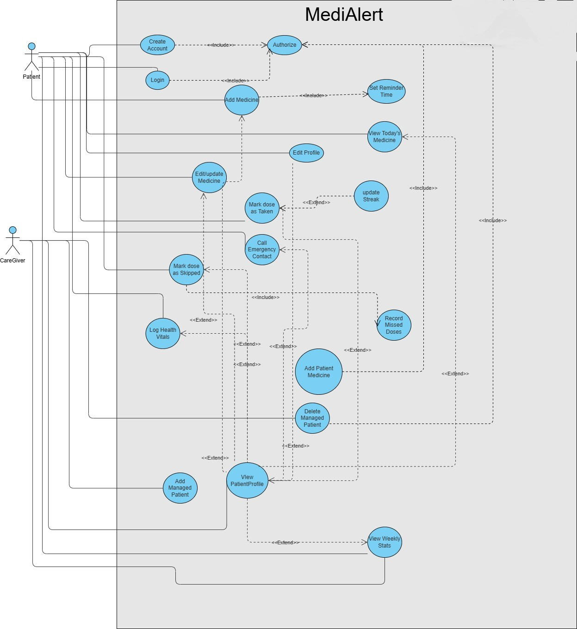

Add Managed Patient

Identifier |  | UC-1
Purpose |  | To allow a Caregiver to create a sub-profile for a patient who does not have their own account, allowing the Caregiver to manage their health data and reminders.
Priority |  | High
Pre-conditions |  | Caregiver must be logged in and authorized.
Post-conditions |  | A new entry is successfully written to TinyDB containing the patient's specific metadata, and this entry is appended to the Caregiver’s 'Managed List' index.
Typical Course of Action
S# | Actor Action |  | System Response
1 | Caregiver taps the "Add Managed Patient" button on the dashboard. |  | System displays the Patient Registration form.
2 | Caregiver enters the Patient's Name, Age,Gender and Emergency Phone. |  | System validates the input data for completeness.
3 | Caregiver clicks "Save Profile". |  | System generates a unique PatientID, stores the record in TinyDB, and updates the Caregiver's dashboard.
4 | Caregiver waits for the confirmation signal. |  | System displays a "Success: Patient Added" toast message..
5 | Caregiver views the updated dashboard list. |  | System refreshes the screen to display the new Patient profile card.
Alternate Course of Action
S# | Actor Action |  | System Response
1 | Caregiver leaves the "Name" or "Phone Number" field empty. |  | System identifies the null value upon clicking the Save button.
2 | Caregiver observes the input validation error. |  | System highlights the empty field in red and displays "Required Field".
3 | Caregiver enters the missing data. |  | System removes the error highlight and enables the Save button.
4 | Caregiver enters a phone number with less than 11 digits. |  | System detects the incorrect length during validation.
5 | Caregiver attempts to save the profile |  | System displays an alert: "Please enter a valid 11-digit phone number"
Table 1: UC-1

Mark Medication as Taken
Identifier |  | UC-2
Purpose |  | To allow the user to record that a specific medication dose has been successfully consumed to ensure accurate adherence tracking.
Priority |  | High
Pre-conditions |  | 1. The user must be logged in to the app.  2. A medication reminder must be currently active or pending in the system.
Post-conditions |  | 1. An intake timestamp is recorded in TinyDB.  2. The daily adherence status for that specific medicine is updated to Completed.
Typical Course of Action
S# | Actor Action |  | System Response
1 | (Background Event) |  | System triggers the notification alarm, plays the alert sound, and displays pill details..
2 | User taps the notification to open the MediAlert interaction screen. |  | System opens the MediAlert interaction dialog.
3 | User taps the "Mark as Taken" button". |  | System dismisses the alarm and mutes the notification sound.
4 | User confirms the medicine was consumed. |  | System generates a timestamp and writes the entry into TinyDB.
5 | User navigates to the Home Dashboard. |  | System refreshes the medicine list and displays a green checkmark
6 | User views the consistency stats |  | System increments the "Current Streak" counter.
7 | User clicks "Back" to exit the screen. |  | System saves the updated state and returns to the main menu.
Alternate Course of Action
S# | Actor Action |  | System Response
1 | User ignores the initial alarm and opens the app 2 hours later. |  | System displays a "Pending/Overdue Dose" alert on the home dashboard..
2 | User taps the "Mark as Taken" button for the overdue medication. |  | System validates the current time against the scheduled time.
3 | User confirms the intake. |  | System logs the entry in TinyDB but flags it as "Late" in the history.enables the Save button.
4 | User checks their progress. |  | System updates the daily record but does not increment the "On-Time Streak" counter.
5 | User taps the notification and selects "Mark as Skipped" |  | System opens a small dialog asking for the reason (Optional).
6 | User selects a reason (e.g., "Out of Stock" or "Side Effects"). |  | System mutes the alarm and stops all reminders for this specific dose.
7 | User views the dashboard. |  | System logs the event as "Skipped" in TinyDB and updates the Weekly Report to show a "Missed" dose.
Table 2: UC-2

View Weekly Stats
Identifier |  | UC-3
Purpose |  | To provide the user (Patient or Caregiver) with a visual summary of medication adherence and health vitals recorded over the previous 7 days.
Priority |  | Medium
Pre-conditions |  | 1. User must be successfully logged in.  2. Adherence or vital data must exist in TinyDB for the specified period.
Post-conditions |  | The system generates and displays a graphical report based on stored logs without altering the database.
Typical Course of Action
S# | Actor Action |  | System Response
1 | User selects the "Reports" option from the main menu. |  | System opens the Reporting Dashboard.
2 | User selects a specific profile (if logged in as a Caregiver |  | System retrieves the PatientID and filters the database logs
3 | User taps on the "Weekly Adherence" tab. |  | System calculates the percentage of doses marked "Taken" vs "Skipped" for the last 7 days
4 | User confirms the medicine was consumed. |  | System calculates the percentage of doses marked "Taken" vs "Skipped" for the last 7 days
5 | User views the generated chart on the screen |  | System renders a bar graph showing daily progress.
6 | User scrolls down to the "Vital Trends" section. |  | System displays a line graph of recorded Blood Pressure or Sugar levels.
7 | User taps the "Home" icon. |  | System closes the report and returns to the main dashboard.
Alternate Course of Action
S# | Actor Action |  | System Response
1 | User opens the report section on a new account with no history. |  | System scans TinyDB and finds no entries for the past 7 days.
2 | User views the blank report screen. |  | System displays a message: "Data insufficient. Please log your doses for a week to see trends."
3 | User taps a specific medicine name from the list. |  | System filters the adherence data for that specific pill only.
4 | User views the filtered results. |  | System updates the graph to show the performance of that individual medication.
Table 3: UC-3

Add Medicine
Identifier |  | UC-4
Purpose |  | To allow the user (Patient or Caregiver) to input a new medication name, dosage, and frequency into the system schedule.
Priority |  | High
Pre-conditions |  | User must be logged in and on the medication management screen.
Post-conditions |  | A new medication schedule is saved in database and a system alarm is scheduled.
Typical Course of Action
S# | Actor Action |  | System Response
1 | User taps the "Add Medicine" (+) button |  | System opens the medication entry form.
2 | User enters the Name of the medicine (e.g., Panadol). |  | System captures the text and moves focus to the dose field.
3 | User enters the Dosage (e.g., 500mg). |  | System validates that the entry is a valid quantity.
4 | User selects the frequency (e.g., Daily). |  | System records the frequency preference.
5 | User triggers the Set Reminder Time (Include). |  | System opens the time-picker widget.
6 | User selects the alarm time (e.g., 08:00 AM). |  | System binds the time to the medication record.
7 | User clicks "Save". |  | System writes the full record to database and schedules a local notification.
Alternate Course of Action
S# | Actor Action |  | System Response
1 | User attempts to add a medicine name that already exists. |  | System checks TinyDB for duplicate strings.
2 | User clicks save. |  | System displays: "Medicine already exists. Do you want to edit the existing one?"
Table 4: UC-4

Log Health Vitals
Identifier |  | UC-5
Purpose |  | To allow the user to manually record physiological data like Blood Pressure or Sugar levels for long-term tracking.
Priority |  | Medium
Pre-conditions |  | User must be on the Health Log screen.
Post-conditions |  | The vital reading is stored with a timestamp in database.
Typical Course of Action
S# | Actor Action |  | System Response
1 | User selects the type of vital to log (e.g., Blood Sugar). |  | System displays the input field for that specific vital.
2 | User enters the numeric value. |  | System validates that the value is within a realistic range.
3 | User adds an optional note (e.g., "After breakfast"). |  | System attaches the note to the data entry.
4 | User clicks "Save Log". |  | System generates a timestamp and saves the entry to TinyDB.
5 | User views the vitals history. |  | System displays the new entry at the top of the history list.
Alternate Course of Action
S# | Actor Action |  | System Response
1 | User enters an impossible value (e.g., 0 or 5000). |  | System detects a range error.
2 | User clicks save. |  | System displays: "Warning: Value out of range. Please verify your entry."
Table 5: UC-5

Requirements Analysis and Modeling
<Include the following analysis models: use-case diagram, state diagram, decision table, event table etc.>

MediAlert Use case diagram:



MediAlert State Machine Diagram:

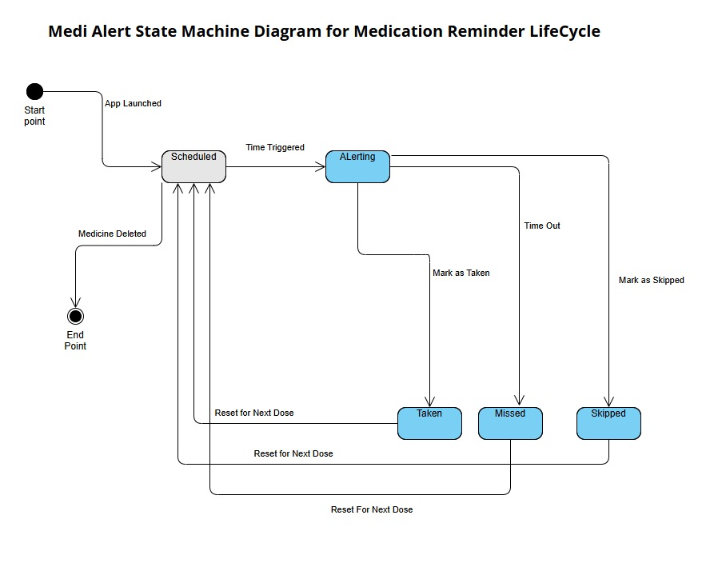

Nonfunctional Requirements*
*make sure all your requirements functional or non functional are testable

Performance Requirements
Performance requirements define how well the system must behave under various conditions. All requirements below are written to be measurable and testable.
5.1.1 App Launch Time
The MediAlert app shall fully load and display the Splash Screen within 3 seconds of being launched on any Android device running Android 6.0 (API 23) or higher, under normal operating conditions (device not under heavy load).
Rationale: Users especially elderly patients should not experience frustrating delays on startup. A 3-second threshold aligns with standard mobile UX benchmarks.
Test: Launch the app 10 times on a mid-range Android device and measure time from tap to Splash Screen display using a stopwatch. All 10 runs must complete within 3 seconds.
5.1.2 Screen Navigation Response Time
Every screen transition within the app (e.g., Dashboard → Medicine List, Dashboard → Vitals Tracker) shall complete and render within 2 seconds of the user tapping the navigation button.
Rationale: Slow screen transitions degrade the user experience and may confuse elderly users into tapping the button multiple times.
Test: Navigate between all 10 screens 5 times each and record transition time. No transition may exceed 2 seconds.
5.1.3 Reminder Notification Accuracy
Medicine reminder notifications shall fire within ±1 minute of the user-configured reminder time, even when the app is running in the background or the screen is locked.
Rationale: The core purpose of MediAlert is timely reminders. A tolerance of ±1 minute is medically acceptable for most non-critical medications.
Test:Set 5 reminders at known times and measure the actual notification delivery time. All 5 must fire within the ±1 minute window.
5.1.4 Data Save Response Time
All user inputs including adding a medicine, logging vitals, or marking a dose as Taken/Skipped shall be saved to TinyDB and confirmed to the user within 1 second of pressing the Save/Confirm button.
Rationale: Quick data persistence ensures users trust that their records are being saved without needing visual feedback delays.
Test: Perform each save operation 5 times and measure the time from button press to on-screen confirmation. All must complete within 1 second.
5.1.5 History Log Load Time
The Medicine History Log and Vitals History screens shall load and display up to 90 days of stored records within 3 seconds.
Rationale: Users tracking long-term adherence must be able to review their history without performance degradation as data grows.
Test: Populate TinyDB with 90 days of simulated history records. Open the History Log screen and measure render time. Must be under 3 seconds.
5.1.6 Offline Operation
100% of the app's core features — including adding medicines, setting reminders, logging vitals, and viewing history — shall function fully without any internet connection.
Rationale: Many target users (elderly, rural patients) may have limited or no internet access. The app must not fail or degrade in offline conditions.
Test: Enable Airplane Mode on the test device and attempt every core feature listed in Section 4. All must function without error.
5.1.7 Local Storage Capacity
The app shall support storage of at least 50 medicine entries, 365 days of adherence history, and 365 days of vitals logs using TinyDB without exceeding a total local storage footprint of 10 MB.
Rationale: TinyDB stores data locally on the device. Storage must remain lean to avoid conflicts with device storage limits on low-end phones.
Test: Populate the app with maximum data (50 medicines, 365-day logs) and check total app storage size under Android Settings > Apps > MediAlert. Must be ≤ 10 MB.
5.1.8 Concurrent Reminder Handling
The app shall correctly fire and display notifications for up to 10 medicine reminders scheduled within the same 24-hour period without any reminder being skipped or duplicated.
Rationale: Some patients (e.g., post-surgery or multi-condition patients) may take many medicines daily. All reminders must fire reliably.
Test: Schedule 10 unique reminders across a single day and verify that all 10 notifications are received and none are duplicated. Pass rate: 10/10.

Safety Requirements
Safety requirements ensure that the product does not cause harm, data loss, or medical risk to users. Given the health-sensitive nature of MediAlert, these requirements are critical.
5.2.1 Prevention of Duplicate Dose Logging
Once a user marks a medicine dose as Taken for a specific time slot, the system shall prevent the same dose from being marked as Taken again for that same slot without first resetting it. A visible warning shall be displayed if the user attempts to record the same dose twice.
Rationale: Accidentally logging a dose twice could mislead the user into believing they have taken more doses than they have, or in the reverse case, prompt an accidental double-dose.
Test: Mark a dose as Taken, then attempt to mark it Taken again without resetting. The system must show a warning and not create a duplicate record.
5.2.2 Emergency Call Confirmation
The one-tap emergency call button on the Dashboard shall display a confirmation dialog ("Call [Contact Name]?") before initiating the phone call. The call must only proceed if the user confirms.
Rationale: Accidental taps on the emergency button by children, caregivers, or the user themselves must be prevented to avoid false emergency calls.
Test: Tap the emergency button 10 times. In all 10 cases, a confirmation dialog must appear before any call is placed. No call shall be made without confirmation.
5.2.3 Emergency Contact Validation
The app shall validate that an emergency contact number entered by the user contains only numeric digits and is between 7 and 15 digits in length (per the ITU-T E.164 standard). The app shall reject invalid entries and display an appropriate error message.
Rationale:A malformed or empty emergency contact number would render the emergency call feature useless in a crisis situation.
Test: Enter invalid inputs (letters, symbols, 4-digit number, blank) into the emergency contact field and verify that each is rejected with an error message. Enter a valid 11-digit number and verify it is accepted.
5.2.4 Data Loss Prevention on App Close
Any data entered by the user (vitals, medicine details, profile) shall be saved to TinyDB before the screen is exited, ensuring no data is lost if the app is closed unexpectedly or the device battery dies mid-entry.
Rationale: Losing health records — particularly vitals readings taken at a specific time — cannot be recovered and may affect health decisions.
Test: Enter vitals data, then force-close the app without pressing Save. Reopen the app and verify the most recently submitted data is retained. (Note: data actively being typed but not yet submitted does not need to persist.)
5.2.5 Clear Data Warning The "Clear All App Data" option in Settings shall require the user to pass through two confirmation steps (e.g., "Are you sure?" → "This will permanently delete all medicines and history. Confirm?") before any data is erased.
Rationale: Irreversible deletion of a patient's entire medication history is a high-risk action. Double confirmation reduces the chance of accidental data loss.
Test: Navigate to Settings > Clear All Data. Verify that exactly two confirmation dialogs appear. Dismiss at the first dialog and verify no data is deleted. Confirm both dialogs and verify all data is cleared.
5.2.6 Missed Dose Logging Accuracy
If a user does not mark a scheduled dose as Taken or Skipped before the next scheduled reminder time, the system shall automatically log that dose as "Missed" and include it in the History Log. No dose shall be silently dropped from the record.
Rationale: Accurate missed-dose records are critical for patients and caregivers to identify non-adherence patterns. Silent omissions could give a falsely positive adherence picture. Test: Schedule a reminder and allow it to pass without any user action. Open the History Log and verify the dose is recorded as "Missed" with the correct date and time.

Security Requirements
Data Protection and Privacy: Since MediAlert manages sensitive personal health information (PHI), it shall prioritize data localization. All medication history, vitals (BP, Blood Sugar), and personal metadata must be stored within the application’s private data directory using the TinyDB component. The system shall not transmit any user data over the internet, effectively mitigating the risk of data breaches from cloud-based vulnerabilities.
User Identity Authentication: The application shall implement a multi-tier authentication protocol:
Initial Registration: Users must register locally with a username and a 4-digit PIN.
Session-Level Security: A PIN-entry screen shall be required whenever the app is launched or resumed from the background to prevent unauthorized physical access.
Role-Based Access: The system shall distinguish between "Patient" and "Caregiver" accounts, where the Caregiver account requires a secondary "Master Password" to modify Patient profiles or delete logs.
External Policies and Regulations: The application is designed to align with the principles of the Health Insurance Portability and Accountability Act (HIPAA) regarding data privacy and the General Data Protection Regulation (GDPR) regarding the "Right to be Forgotten" (allowing users to permanently delete all local logs via the settings menu).
Privacy Certifications: While the prototype is a standalone tool, the design architecture is ready for ISO/IEC 27001 (Information Security Management) standard compliance. The app shall utilize the Android Sandbox environment, which is a certified security layer for mobile application isolation.

Additional Software Quality Attributes
Usability (Ease of Use vs. Learning): Priority: Ease of Use. Since the target audience includes elderly users with potentially low technical literacy, the system shall prioritize an intuitive, "one-tap" interface. The app shall require no more than 10 minutes of initial learning time for a new user to successfully add a medication.
Reliability: The system shall maintain a Mean Time Between Failures (MTBF) of at least 5,000 hours of operation. The medication alarm service must have a success rate of 99.99% for triggering notifications at the exact scheduled timestamp.
Correctness: The health analytics engine must ensure 100% accuracy in streak calculations. If a dose is logged at 11:59 PM, it must be attributed to the correct calendar day to prevent logic errors in adherence reports.
Portability: The application shall be compatible with Android API Level 21 (Android 5.0) and above. It must maintain consistent UI rendering on screen sizes ranging from 4.5 inches to 10.1 inches (Tablets).
Robustness: The system shall be "fault-tolerant." If the application crashes during a data-write operation to TinyDB, it must utilize a "last-known-good" backup to prevent database corruption.
Testability: The modular design of the MIT App Inventor blocks shall allow for System Testing with a 100% pass rate for all 5 core Use Cases (UC-1 to UC-5) before the final APK build

Other Requirements
Database Requirements: The application requires a local, persistent key-value store. This is fulfilled by TinyDB, which must handle a minimum of 2,000 individual log entries without exhibiting lag in retrieval time. Data must persist across app updates and phone restarts.
External Interface Requirements:
Hardware Interface: The system requires access to the device’s internal clock, vibration motor, and audio speaker. It also requires access to the cellular radio (SIM card) to perform the Emergency Calling feature.
Software Interface: The app shall interface with the Android AlarmManager to ensure background notifications. It also interfaces with the Android Dialer to pass the emergency contact number for immediate calling.
Communication Interface: No external communication interfaces (Wi-Fi/Bluetooth) are required for core operation, maintaining the "Offline-First" design.
Internationalization: The initial version shall support English (UK/US). However, the UI architecture shall be "string-resource ready," allowing for future localization into Urdu or other regional languages by replacing the text on button components and labels.
Legal Requirements: The app shall include a mandatory End-User License Agreement (EULA) that must be accepted during registration. It must clearly state that MediAlert is a supportive tool and is not responsible for any adverse health outcomes resulting from user-controlled data entry errors.
Reuse Objectives: The logic blocks for the "Medication Scheduler" and "Vitals Range Checker" shall be designed as modular, reusable components. This enables future developers to integrate these features into larger healthcare systems or hospital-specific management apps with minimal code changes

Designing

Complete class diagram
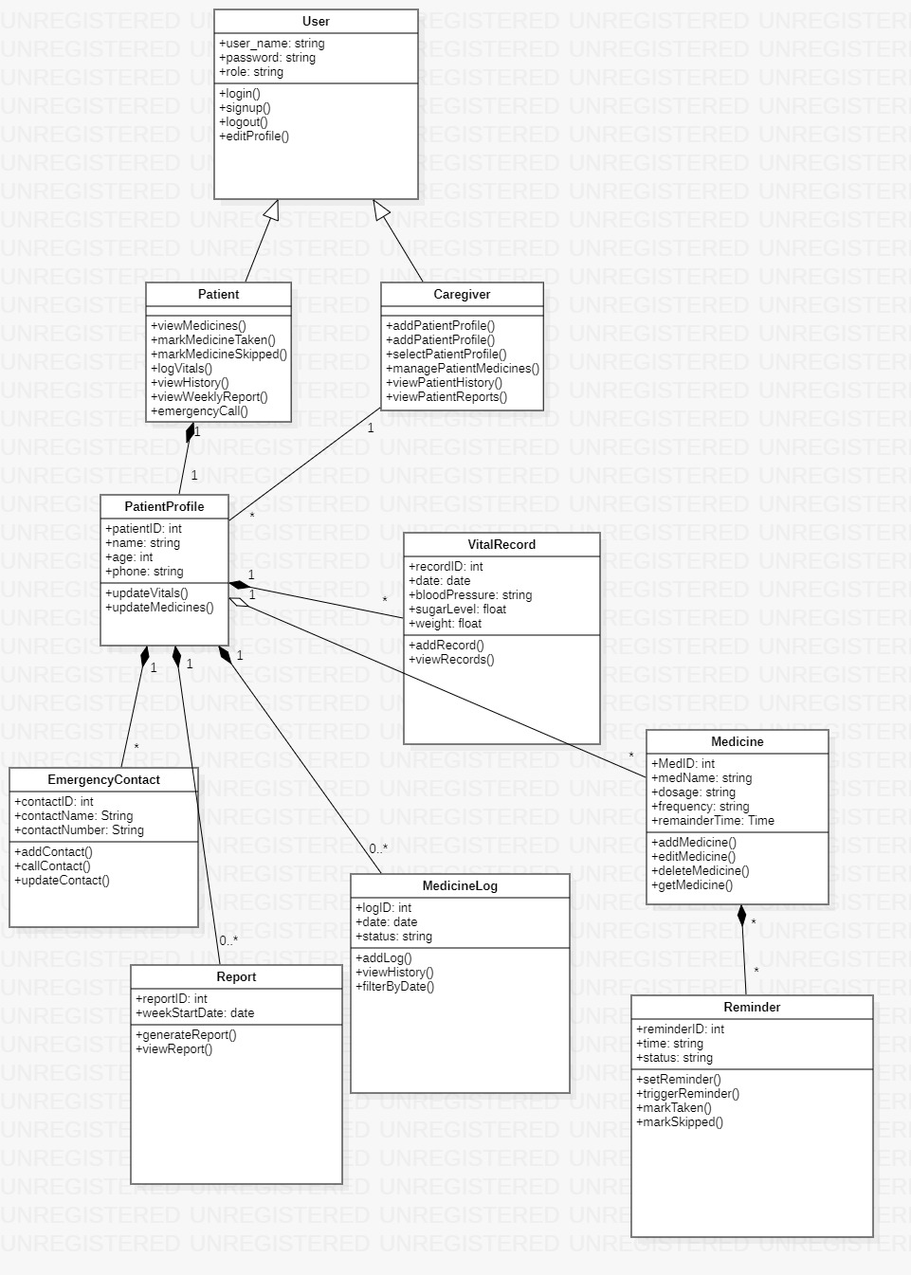

Complete Data Flow Diagram (DFD)

Context DFD (LEVEL 0)

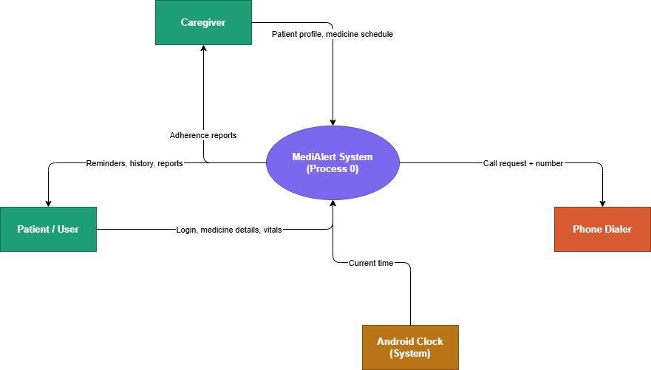

LEVEL 1 (DFD)

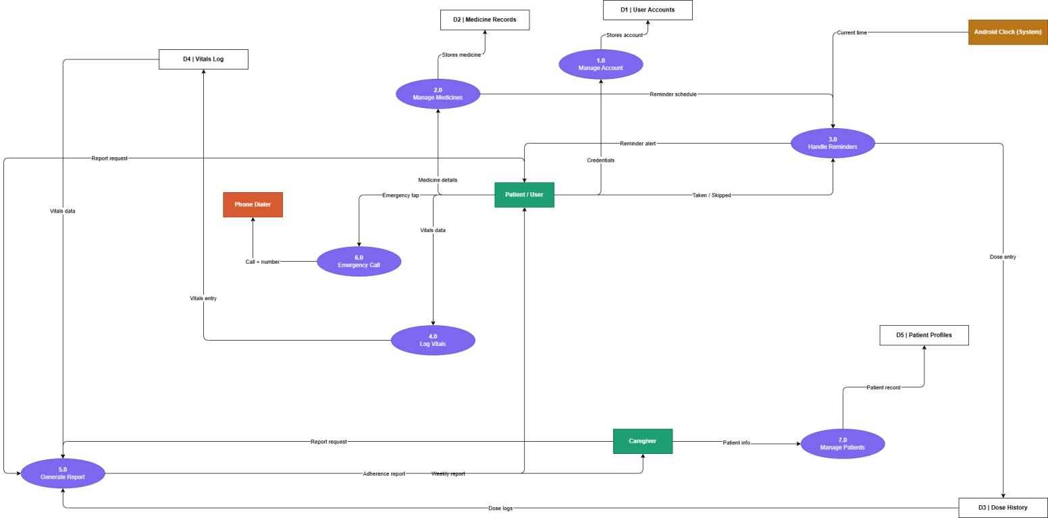

Complete ER Diagram
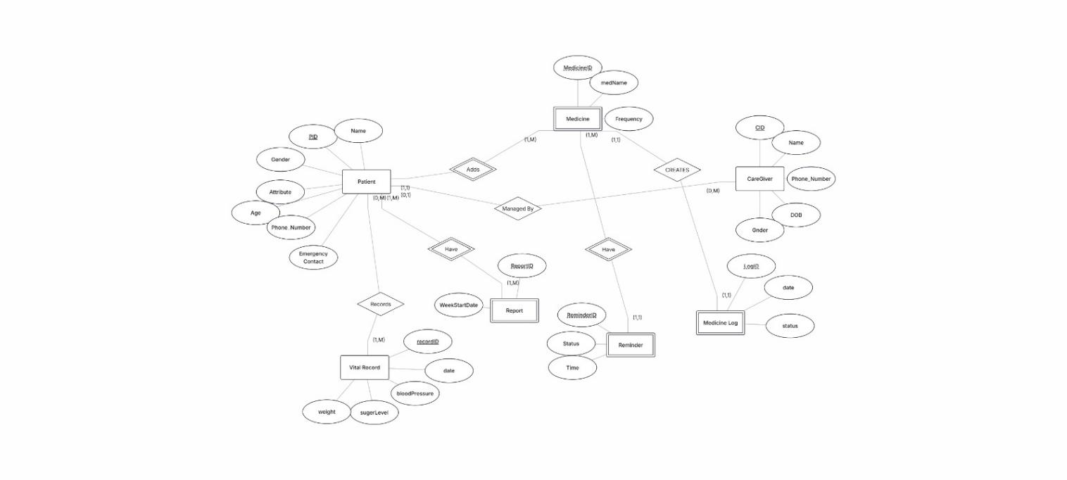

Physical design of your database
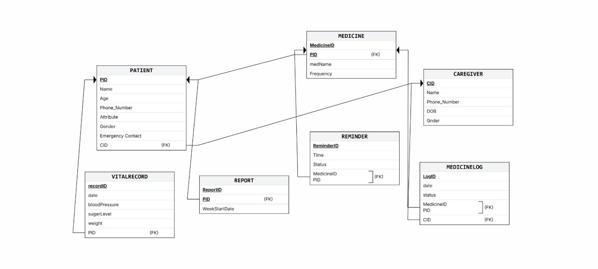

Make a Sequence and a Collaboration diagram of following.

Scenario 1
Marking Medication as Taken.

Sequence Diagram:
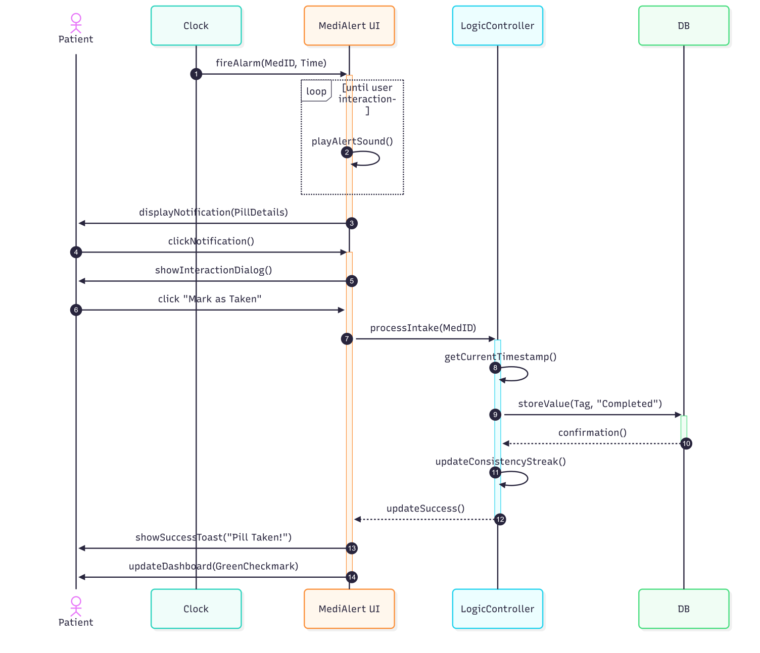

Collaboration Diagram:

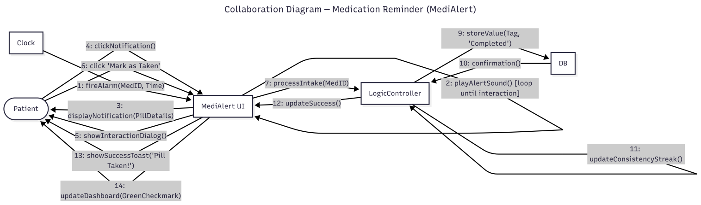

Scenario 2

Adding a Managed Patient Profile

Sequence Diagram:

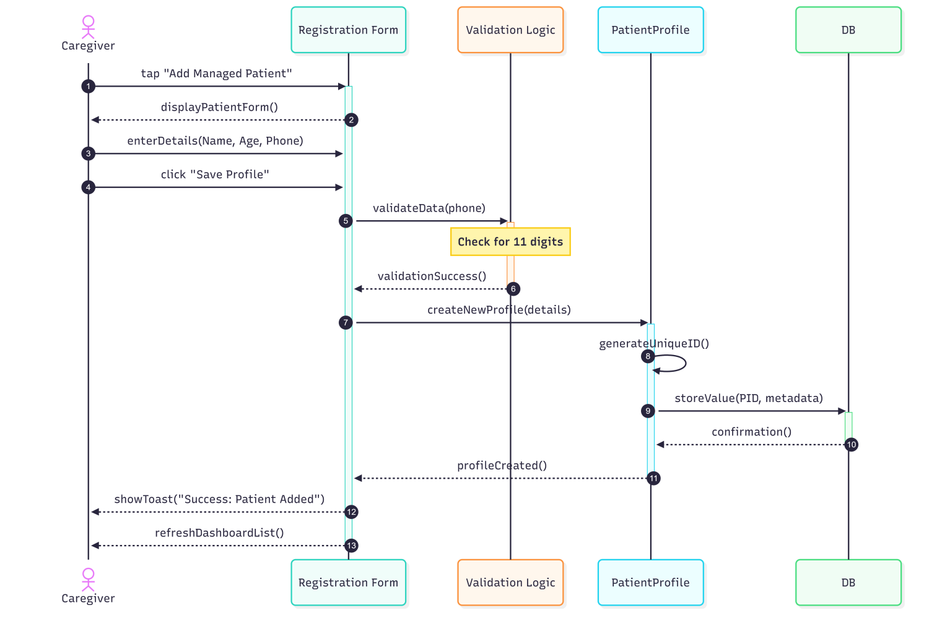

Collaboration Diagram:

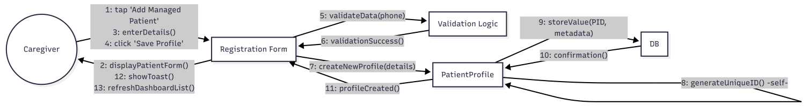

Estimation

Cost Benefit Estimation

Return of Investment (ROI) {1st year}
<Approximate estimations should be done after approximate estimation of values.
Formula of ROI = Benefits / Cost >

Parameter Category | Description | Assumed Value (PKR)
Development Cost | Labor equity for 4 engineers, UI design assets, and local testing environment. | 180,000 PKR
Benefit | Hosting infrastructure savings (due to offline-first design) and local healthcare public utility value. | 270,000 PKR

ROI = Benefit / Cost

ROI = 270,000 / 180,000 = 1.50 (for 1 year)

%gain on ROI {1st year}
Percentage Gain on ROI = ( (Benefit - Cost ) / Cost ) * 100

Percentage Gain on ROI = ( 270,000 - 180,000 ) / 180,000 = 0.5

%gain on ROI = 0.5 * 100

%gain on ROI = 50%

Payback Period in years

Formula of payback period = Cost / Benefit >

Payback period = 180,000 / 270,000

Payback period = 0.666

FP based Estimation

Component Type | Description / System Elements | Count | Complexity Weight | Total FP
External Inputs (EI) | Login, Sign Up, Add Medicine, Log Health Vitals, Add Managed Patient | 5 | 4 (Average) | 20
External Outputs (EO) | Alarm Reminder Notification, Emergency Call Trigger | 2 | 5 (Average) | 10
External Inquiries (EQ) | View Medicine History, View Vital Logs, View Weekly Stats | 3 | 4 (Average) | 12
Internal Logical Files (ILF) | User Accounts, Medicine Schedules, Dose Logs, Vitals Stores | 4 | 7 (Average) | 28
External Interface Files (EIF) | Android System Clock API, Native Device Cellular Radio | 2 | 5 (Average) | 10
Total UFP | Sum of all unadjusted function points |  |  | 80 FP

Final Adjusted FP = UFP x VAF

Final Adjusted FP = 80 * 1.0

Final Adjusted FP = 80

COCOMO Estimation
Visual Language Mapping Factor: 1 FP = 32 Equivalent Lines of Code (LOC) assuming for MIT APP Inventor Block Code

KLOC = 80 x 32 = 2560 Lines = 2.56 KLOC

Organic Project Coefficients
Effort Constants: a_b = 2.4, b_b = 1.05
Schedule Constants: c_b = 2.5, d_b = 0.38

Execution Calculations

Metric Parameter | Software Engineering Formula | Value Substitution | Calculation Step | Final Project Metric
1. Total Effort | Effort = a_b * (KLOC)^b_b | Effort = 2.4 * (2.56)^1.05 | Effort = 2.4 * 2.687 | 6.45 Person-Months
2. Development Time | TDEV= c_b * (Effort )^d_b | TDEV= 2.5 * (6.45)^0.38 | TDEV= 2.5 * 2.023 | 5.06 Months
3. Recommended Staff | STAFF = Effort / TDEV | STAFF = 6.45 / 5.06 | STAFF = 1.274 | 2 Software Engineers

References
<List all books, conference papers, journal articles, websites, etc. used in preparing the content of this SRS. Provide enough information so that the reader could access a copy of each reference, including title, author, volume/edition number, page number(s), and publication year. Mention complete URLs for websites.>
< Must use Zotero reference Manager to maintain references in every phase in this section.>

Appendix A: Glossary
<Define all the terms necessary to properly interpret the SRS, including acronyms and abbreviations. You may wish to build a separate glossary that spans multiple projects or the entire organization, and just include terms specific to a single project in each SRS.>

